FRIENDS AND FAMILY TEST
Results for June 2024

Thank you to all the patients who completed a friends and family test survey in June 2024.

How likely are you to recommend our practice to family and friends if they needed similar care or treatment?
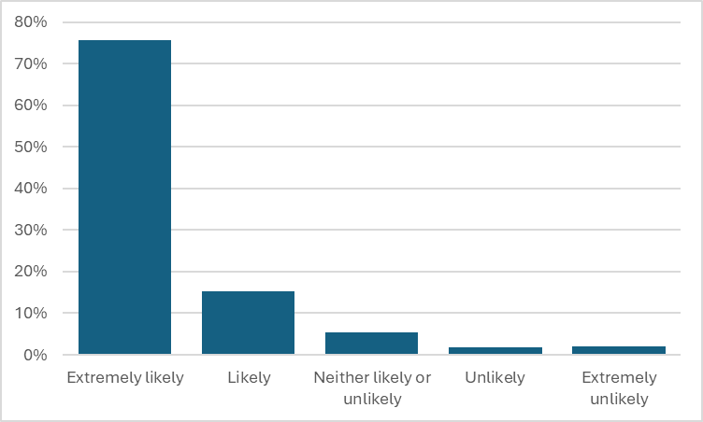
76% are extremely likely to recommend the practice
15% are likely to recommend the practice
5% are neither likely nor unlikely to recommend the practice
2% are unlikely to recommend the practice
2% are extremely unlikely to recommend the practice

If we could change one thing about your care or treatment, what would it be?
- Top class treatment with Dr Hart and the nurse.
- Dr Hart, Tom and all the team at Coppull provide a first-class service to their patients.
- Dr Harris was very easy to talk to and helpful. Dr Harris is wonderful and is always very patient and willing to discuss concerns and treatment options.
- Dr Hart is absolutely brilliant. Dr Hart is an amazing, lovely and friendly lady.
- Dr Rawson is so caring and patient.
- Dr Craghill was very personable and professional all at the same time.
- The ANP was great. Messaged that morning with request and seen the next day. Perfect.
- Big shout out to the nurses. Can’t fault the service they give and go above and beyond.
- Carol was fantastic.
- Tracey was professional, efficient and had a great ‘bedside manner’.
- You give your all already. I don’t think it needs improving.
- The doctors I’ve seen are caring along with all the staff. Excellent service.
- Reception staff and nurses very friendly and professional.
- The nurse was very kind and made me feel at ease. She was perfect.
- So grateful to the wonderful team at Coppull Medical Centre – they should be an ambassador for the NHS.
- Nothing, was a rapid appointment, was on time and I was listened to.
- I realise how fortunate I am to be a patient at Coppull Medical Practice.
- Staff to be a little more considerate and cheerful.
- On occasion, communication could be better.
- Getting to see a doctor has become quite a stressful experience.
- I don’t like the appointment system. Make it easier to book appointments.
- More face-to-face appointments.
- I found the website difficult to navigate to find how to book an appointment.
- I’ve recently seen the same doctor twice and, on both occasions, she was very patronising and very rude. She talked over me when asking questions.
- Make it easier to get an appointment. Shorter waiting times.
- It would be helpful if you could complete the triage form at any time of the day and not just between 7am and 12pm.

